**Yancey County**

**4-H Presentations 2018**

**Activity Day**

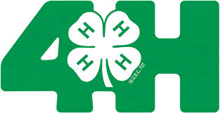

**EARN  
AWARDS**

**MAKE FRIENDS**

**SHARE**

**WITH**

**OTHERS**

**LEARN**

**CAREER**

**SKILLS**

**Who: Youth Ages 9-18 (prior to of January 1, 2018) Registration required**

**When: County Activity Day May 11, 2018 (2 winners chosen from each category)**

**County Winners compete at West District Activity Day June 23 in Madison County**

**District Winners compete at State Presentation Finals in Raleigh July 21**

**What: Oral presentation (Illustrated talk or demonstration on a topic of choice)**

**Presentation Regulations**

<https://nc4h.ces.ncsu.edu/youth-3/4-h-awards-incentives-programs-2/presentations/>

**Where: NC Cooperative Extension - Yancey County 4-H**

**30 East U.S. Hwy 19E Bypass, Burnsville (828) 682-6186**

**Why: Develops self-confidence & communication skills**

**32 Categories: Ages 9-10, 11-13, 14-18 (5-8 noncompetitive)**

**How: Project Research - Outline – Speech – Posters or PowerPoint – Props –**

**Practice.....Practice.....Practice**

**Registration Required by Tuesday, May 1st: Forms & Instructions available at 4-H Office**



NC State University and N.C. A&T State University are collectively committed to positive action to secure equal opportunity and prohibit discrimination and harassment regardless of race, color, national origin, religion, political beliefs, family and marital status, sex, age, veteran status, sexual identity, sexual orientation, genetic information, or disability.