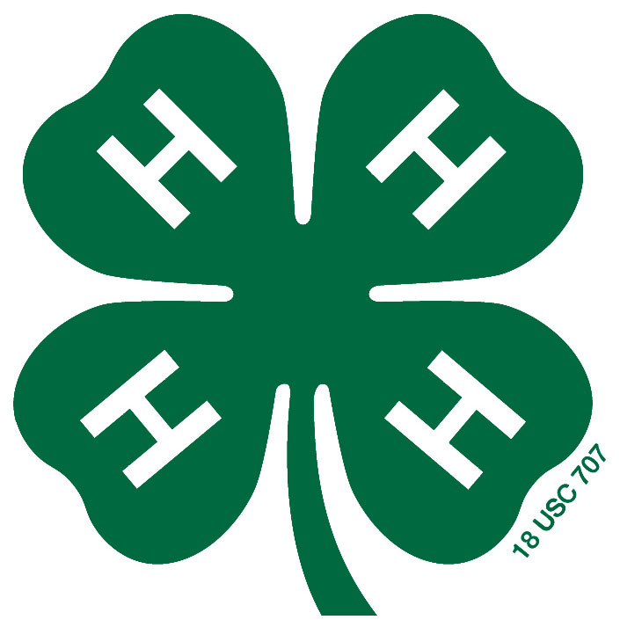
Yancey County 4-H Presentations Registration

Due in 4-H Office by: Friday May 3rd, 2019

Name: _______________________________________________________________
Address:______________________________________________________________
City:_______________________ State: NC Zip______________ District: West County: Yancey

Phone number: ___________________________________ Sex: Male _____ Female _____
Race: White or Caucasian ___ Black or African-American ___ Asian ___ Native American or Alaskan Native ___ Native Hawaiian or Pacific Islander ___ Hispanic ___ Other ___
Collected in compliance federal requirements intended to insure equitable program administration and availability.
Age (as of January 1, 2019): __________ Birthdate: _____________________
Age eligibility is established on January 1st of the current year. To participate in competition, the 4-H member must be nine years of age prior to January 1st of the current year and not have had his/her 19th birthday before January 1st of the current year. Divisions are 9-10, 11-13, and 14-18.

4-H Presentation Regulations can be found at:
https://nc4h.ces.ncsu.edu/youth-3/4-h-awards-incentives-programs-2/presentations/
Please familiarize yourself with the regulations as some categories have different instructions.
County competition will be judged to determine two county winners to compete at West District Activity Day June 15 in McDowell County. Cloverbud category is non-competitive.

Please direct any questions to: Linda Semon or Tres Magner 828-682-6186

Presentation Category: ________________________________________________

Name of Presentation: _________________________________________________

Each county may enter only two presentations to District Activity Day per age category. 4-H members may compete in no more than one presentation program per year.

"4-H Entertains" is not considered a presentation program. Please read rules for entry at:

https://nc4h.ces.ncsu.edu/youth-3/4-h-awards-incentives-programs-2/presentations/presentation-guidelines-4-h-entertains-2/

I would like to perform in the following category:
4-H Entertains: Team? No _____ Yes _____
Title of Presentation for 4-H Entertains: _____________________________________________________

Type of Act: ___________________________________________________________________________

Equipment required: _____________________________________________________________________

