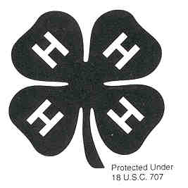
Project Record

5-8 Year Old

_______________________
Project Name

Your Name ____________________________________________________

Mailing Address ________________________________________________

City________________________________Zip Code___________________

Group Name ____________________________________________________

Birthdate: Month ______________ Day_________ Year_________________

I like participating in 4-H because __________________________________

_______________________________________________________________

_______________________________________________________________

_______________________________________________________________

_______________________________________________________________

Dear 4-H’ers and Helper,
This Project Record form is designed to help a young child record and recognize their accomplishments. Any help that a child receives from a parent, volunteer, or any other
adult is a very positive addition to the project and the project record form as long as the
child is encouraged to do as much as possible themselves. If needed, the writing can be
dictated to the helper. If more space is needed, add extra sheets of paper. Good Luck!

Things I learned and did in my project:

(Examples)
I learned to measure dry ingredients.
I learned to make a paper airplane.
I learned to make a puppet out of a paper bag.

1.

2.

3.

4.

5.

6.

7.

8.

9.

10.

11.

12.

My 4-H Story

My favorite part of this 4-H Project was _______________________________________________

The hardest part about my 4-H Project was ___________________________________________

The funniest part about my 4-H Project was ___________________________________________

Something else I want you to know about my project is__________________________________

Who helped you with this project?___________________________________________________

Draw a picture of something you did in your project.

Other things (non-project) I have done in 4-H this year:

(Examples)
Attended 8 club meetings
Went to 4-H Summer Day Camp
Participated in Big Sweep clean up

1.

2.

3.

4.

5.

6.

7.

8.

9.

10.

11.

12.

Attach two photographs showing you working in this project. Write a caption underneath each picture telling what is happening.

If you would like, add up to two more pages of non-photo items that show things you have done in 4-H this year. This might be a news clipping, drawings of your work, collages, poems, or other creative ways of showing your involvement in 4-H. Make sure that what you include is related to what you do in 4-H.

